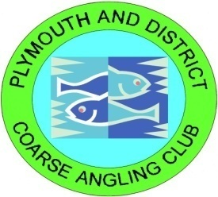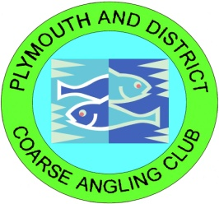

Dear member.

Welcome to you, old and new I’m the club secretary Bill Cox, welcome and happy New Year to you. The following items of interest and information are intended for your perusal, one of the ways we try to keep in touch with the members is with these newsletters. You can also get a lot of up to date info from our facebook pages at P.A.D.C.A.C or our website at [www.padcac.co.uk](http://www.padcac.co.uk) and if it’s really urgent you can ring any of the bailiffs or committee members using the numbers provided in your books and on the opposite side of this page. …………….==============================🡺

We have lost two long serving committee members this year, Brian Morrell who was Chairman and vice chairman for many years and Alan Stevens a bailiff and the clubs data keeper have both sadly died, they will be sorely missed and our condolences go out to both there family’s ! R.I.P guys. Also after several years on the committee Gary Beasley Head bailiff at Cadover has stepped down due to personal issues and Dicky Billingham the ass match secretary also leaves us to spend more time away with his wife in there caravan. We the committee would like to take this opportunity to thank them for all the time and hard work they have put in for PADCAC and wish them well for the future. People leaving inevitably mean people joining and we welcome Jason Wark to the committee who joins us as a bailiff. Paul Reed who will run the Carp matches for us, Paul Bennett who takes over as Chairman, John Thompson who will bailiff and is also the clubs head coach, Andrew Mitchell who will bailiff and also Pat Whymer who will step in as Vice Chair / bailiff and Nick Newns as assistant match secretary. Finally we welcome back Sarah Morrell who is going to help me out as assistant secretary. We come out of another year interrupted by covid and lockdowns hopefully 2022 will bring new hope that things can get back to normal, please remember that if we issue new rules to comply with the covid restrictions it is as much a pain for us as we are all club members too and we want to fish as well. If we all do what we have to do and keep ourselves and others safe it will only help the bigger picture.

***Bill Cox – Club Secretary***

**Weil’s disease** (Leptospirosis)

Where there is water you will often find rats, so the committee would like to remind all members to pay special attention to cleanliness whist fishing at our venues. It would be worthwhile carrying a small bottle of hand sanitizer to use on their hands before eating any food. Weil’s disease is carried by rats and is potentially lethal and care should be taken especially with open cuts or wounds. If you become ill after a fishing trip please tell your doctor of the potential contact so he can consider Leptospirosis in his diagnosis.

Below is a list of committee members for this year, if you have any problems please do not hesitate to phone any of them. That is what they are their for!!

COMMITTEE

**Chairman: - Paul Bennett**

**07476862728**

**Vice Chairman: -** **Pat Whymer**

**07476214212**

**Treasurer: - Mark Chanter**

**07810548445**

**Secretary*: including publicity* - Bill Cox**

**Tel: 01752 317329 Mob:07821644314**

**Match Secretary: - John West**

**Tel: 01752 895317 Mob:07969860947**

**Assistant match Secretary: - Nick Newns**

**7920262480**

**Specimen Officer: - Phil Hawkins**

**07970956862**

**Water Bailiffs**

*Cadover Head Bailiff –* **Peter Thompson– 07729051878**

*St Germans Head Bailiff –* **Tom Dolman – 07758833712**

*Filham Park Head Bailiff -* **Richard Godward – 07958395654**

**Steve Manlow – 07986133467 *Padcac coach***

**Tristan Causer –** **07876394622**

**Jason Wark – 07528177007**

**Phil Hawkins – 07970956862  *Including Specimen officer***

**Mark Chanter – 07810548445**

**Paul Reed – 07496482964 *Including carp matches***

**Tom Dolman – 07758833712**

**Andrew Mitchell – 07570570665**

**John Thompson - 07525713833 *Padcac Head coach***

**Pat Whymer - 07476214212**

|  |  |  |  |
| --- | --- | --- | --- |
| ***Cadover Wednesday Evening Coarse League 2022*** | | | |
| Day | Date | Venue | Type |
| Wednesday | 11-May-22 | Cadover | Wed Eve |
| Wednesday | 25-May-22 | Cadover | Wed Eve |
| Wednesday | 08-Jun-22 | Cadover | Wed Eve |
| Wednesday | 22-Jun-22 | Cadover | Wed Eve |
| Wednesday | 06-Jul-22 | Cadover | Wed Eve |
| Wednesday | 20-Jul-22 | Cadover | Wed Eve |
| Wednesday | 03-Aug-22 | Cadover | Wed Eve |
| ***Filham Wednesday Evening Coarse League 2021*** | | | |
| Day | Date | Venue | Type |
| Wednesday | 04-May-22 | Filham | Wed Eve |
| Wednesday | 18-May-22 | Filham | Wed Eve |
| Wednesday | 01-Jun-22 | Filham | Wed Eve |
| Wednesday | 15-Jun-22 | Filham | Wed Eve |
| Wednesday | 29-June-22 | Filham | Wed Eve |
| Wednesday | 13-July-22 | Filham | Wed Eve |
| Wednesday | 27-July-22 | Filham | Wed Eve |

**Baz Philips Memorial Trophy *( Fur & Feather)***

Sunday 02nd Oct-21 Cadover Main Lake

**2021 / 2022 Winter Match League, Sundays**

|  |  |  |  |
| --- | --- | --- | --- |
| Sunday | 07th -Nov-21 | Cadover | Coarse winter |
| Sunday | 14th -Nov-21 | St Germans | Coarse winter |
| Sunday | 28th -Nov-21 | Filham Park | Coarse winter |
| Sunday | 05th -Dec-21 | Awayday (TBA) | Coarse winter |
| Sunday | 02nd –Jan-22 | Awayday (TBA) | Coarse winter |
| Sunday | 16th -Jan-22 | Filham Park | Coarse winter |
| Sunday | 06th -Feb-22 | St Germans | Coarse winter |
| Sunday | 06th -Mar-22 | Cadover | Coarse winter |

**2022 / 2023 Winter Match League, Sundays**

|  |  |  |  |
| --- | --- | --- | --- |
| Sunday | 06th -Nov-22 | Cadover | Coarse winter |
| Sunday | 13th -Nov-22 | St Germans | Coarse winter |
| Sunday | 27th -Nov-22 | Filham Park | Coarse winter |
| Sunday | 04th -Dec-22 | Awayday (TBA) | Coarse winter |
| Sunday | 08th –Jan-23 | Awayday (TBA) | Coarse winter |
| Sunday | 22nd -Jan-23 | Filham Park | Coarse winter |
| Sunday | 05th -Feb-23 | St Germans | Coarse winter |
| Sunday | 05th -Mar-23 | Cadover | Coarse winter |

**Inter club Match**

*Against Bideford Angling Club Home and away Coarse Match rules*

Saturday 09th July 2022 Cadover Home

Saturday 23rd July 2022 Tarka swims Away

**Annual Charity weekend matches**

***Alan Stevens memorial Carp Match***

Sat 9th April Filham Park Lake 8am till 6pm

***Brian Morrell Memorial Coarse Match***

Sunday 10th  April Cadover Main Lake 10am till 4pm

***All proceeds to Cancer research charities***

**Note:- Please remember that on match days the affected lake will be closed if 8**

**or more anglers are fishing the match.**

**Anyone wishing to fish in any of the above events needs to**

**ring the match secretary - John West -** 07969860947

**or carp match secretary – Paul Reed –** 07496482964

**Night fishing (*Covid permitting*)**

Night fishing is allowed on all of our waters. Please leave your swim tidy when you leave for the next member who wants to use it .**TAKE YOUR** **LITTER HOME!** I would like to point out to older members rejoining that after an AGM ruling in 2005 **Three rods will no longer be permitted between dusk and dawn during the months March through October.** I would also like to draw your attention to the fact that **Night fishing is not permitted on our lakes for juniors unless accompanied by an adult** .the reason for this unpopular rule is, that our insurance will not cover us for unaccompanied juniors at night.

**Matches (*Covid permitting*)**

The club runs a match circuit for the match fisherman amongst you and a Carp match league for all you carpers. Last year the matches were a great success so if you feel inclined please feel free to enter. I have included a list of match dates / venues below so you can pin it up somewhere to remind you, but the dates are also in your club membership book.

**24 HOUR CARP MATCHES**

***Bill cox carp match league 2022***

|  |  |  |
| --- | --- | --- |
| Sat / Sun | 12th / 13th Mar 2022 | Cadover ML |
| Sat / Sun | 14th / 15th May 2022 | St Germans |
| Sat / Sun | 18th / 19th Jun 2022 | Cadover LL |
| Sat / Sun | 16th / 17th Jul 2022 | Cadover ML |
| Sat / Sun | 30th / 31st Jul 2022 | St Germans |
| Sat / Sun | 13th / 14th Aug 2022 | Cadover LL |
| Sat / Sun | 10th / 11th Sep 2022 | Filham Park |
| Sat / Sun | 08th / 09th Oct 2022 | Filham Park |

**Please note** ***LL = Lower Lake* and ML = Main Lake**

**Cadover Sunday Coarse Match League2022**

|  |  |  |  |
| --- | --- | --- | --- |
| Sunday | 24th April | Cadover | Sunday League |
| Sunday | 22nd May | Cadover ( Del Colman) | Sunday League |
| Sunday | 12th June | Cadover | Sunday League |
| Sunday | 10th July | Cadover | Sunday League |
| Sunday | 07th August | Cadover | Sunday League |
| Sunday | 04th Sept | Cadover | Sunday League |
| Sunday | 02nd Oct | Cadoverfur & feather | Sunday League |
| Sunday | 23rd Oct | Cadover | Sunday League |

**Filham / St Germans Sunday Coarse Match League 2022**

|  |  |  |  |
| --- | --- | --- | --- |
| Sunday | 03rd April | St Germans Lake | Sunday League |
| Sunday | 08th May | Filham Park Lake | Sunday League |
| Sunday | 29th May | St Germans Lake | Sunday League |
| Sunday | 03rd July | Filham Park Lake | Sunday League |
| Sunday | 24th July | St Germans Lake | Sunday League |
| Sunday | 21th Aug | Filham Park Lake | Sunday League |
| Sunday | 18th Sept | St Germans Lake | Sunday League |
| Sunday | 16th Oct | Filham Park Lake | Sunday League |

**ibook*…***

As you will all know in 2020 we introduced the ibook system in order to both facilitate online membership and to run the new booking system. This system works very well and allows us to control the waters better and respond easily and quickly to any unforeseen events. Would members who book a swim and don’t show up which happens to us all from time to time please remember to cancel your booking asap so somebody else can use the slot if they want to. Remember If you have trouble at anytime, and a family member or friend is unable to help you, then please as a last resort contact Mark Chanter, Bill Cox or any other committee member. to get yourself booked in manually but please try and use the system.

**Specimens**

Hi all   
l will again be doing a monthly specimen report on the P.A.D.C.A.C pages and would really like **YOU** the members to start reporting specimen catches

Your catches can be reported to me initially by telephone   
07970956862  
Or by Email   
phil.hawkins@tiscali.co.uk  
Or via Facebook Messenger   
Please attach a picture taken of the fish if available

All specimen entries must be witnessed by a non-related club member and I will need their name and membership number in case they need to be contacted regarding the specimen

All specimens reported will be noted with myself and the committee every month. The best specimen of each species reported by the closing date of the 20th October 2021 will be awarded with a certificate at the clubs AGM meeting in November 2021, some species even have trophys.

I will post a monthly reminder on the Facebook pages on the 3rd weekend of every month to remind you to submit your specimen catch. Please note. No pictures of fish are to be published on the public page

Thank you very much and look forward to hearing about your catches..........***Phil Hawkins, Bailiff / Specimen Officer***

**Bailiffs**

It’s a sure bet that sometimes throughout the year you will be asked to produce your club membership and / or EA license. Please do not take this personally the Bailiffs and other club officials are only looking after all of our interests.

Anyone who sees anything suspect going on or strangers lurking around should report it to a bailiff or committee member as vigilance is our best defence against poaching and vandalism.

**Rules**

A complete list of the clubs rules and constitution are printed in your members handbook and also on ibook and the padcac website, please familiarize yourself with them as your membership is dependant on your complying with them.

**Skin abrasions**

Allmembers are asked to carry a fish skin abrasion treatment such as Klinic or even Bonjella. All fish caught carrying spawning marks, heron/cormorant damage, ulcers or skin/mouth damage of any sort should be liberally treated. You can buy propriety made kits but Bonjella will do, its £1 in superdrug This club belongs to all of us! Please help to keep it healthy.

**Nets**

All of our waters hold large carp in excess of 20lbs so its

only right in a club that cares for its fish that members can

deal safely and carefully with large fish if skilful enough to land them. members often say “ I’m only fishing for

small stuff, I only need a spoon net” trouble is the 20lb carp that decides it likes the look of your corn or maggot etc does not know that. Use your spoon net for small stuff and your Carp net is on hand just in case. There is no rule you have to have a spoon net as well as a Carp net only that you must have a 30” minimum net. If you fish predominantly for carp and your happy to net other species in your carp net then that’s fine. If you fish predominantly for small stuff you may well decide to carry a spoon net as well. I would draw your attention to rule12 which states that **All** fish over 6 ounces must be netted and not swung in, All fish to be landed and unhooked safely and in accordance with club rules  no fish are to be unhooked in the water.

**Net care**

The EA say that in almost all cases of disease found in fish the majority of the time it originates from and was transported from an infected lake on a wet net. The

best way to prevent this spread is to thoroughly dry nets in

between fishing sessions. So please air dry your nets and

keepnets. Anyone caught unpacking a wet net will be asked to leave the lake until they can show a dry net.

**Lake maintenance**

This coming year we have a lot of work needed that can not be put off, Cadover back bank walkways and bridges are fast reaching the end of their life, this work alone will cost in the region of £8,000 and take most of the summer over several work parties. Also at Filham we need to continue the work we started last year replacing the swim platforms, we did 10 last year and hope to do the last 10 this year this will cost again at today’s prices around 8k just for materials. Add to that some spot repairs at St Germans and the ongoing struggle on Cadover lower lake to improve the habitat and stop the bank erosion and its not hard to see why we had no choice but to increase fees from this year. Most of this work is a health and safety concern and must be done ASAP. Please keep a look out on the FB pages and on the website and try and help out at any work partys you can attend.

Lastly as mentioned above the erosion on the lower lake is a big concern and we hope to put a temporary fence along the back bankl to keep the cattle off so we can repair the margins and protect it with willow weave which should grow and stabilize the bank. This is the least expencive option and in fact if we harvest the willow from Filham when its cut back in the spring it will only really cost the outlay for the temporary fence. It is however as always labour intensive so please please try and help if you can even if its only for half a day.

**Privacy policy**

The clubs privacy policy is included in this pack to comply with the Data protection Laws.

**Fish Stocking**

The club has fish stockings planned for 2022 at St Germans when we will stock silvers in January/February and also £2,000 worth of fish from Milemead mostly silvers and bream which we have still to decide where we will put them. £600 has been set aside to buy some more Tench for the Tench pond at Cadover also expected to be done in early spring 2022.

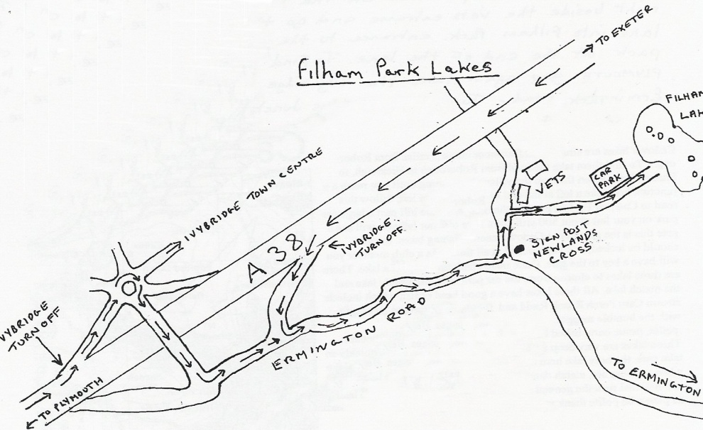

**Filham Park Lake**

From Exeter take the A38 south towards Plymouth, take the slip road marked Ivybridge. Turn left off slip road onto the Ermington road, follow until you reach a left turn signed newlands cross. Turn left into it and the entrance to the lake is about ¼ of a mile along the road on the right through the gate next to the Vets practice. From Plymouth take A38 north towards Exeter, take slip road for Ivybridge. At the top of the slip road take the 5th exit off the roundabout and go across the bridge over the A38. take the first left turn sign posted Ermington. Once on the Ermington Road follow the directions as above.

